**FAITH JUNIOR SCHOOL-KASENGE**

**PRIMARY FOUR EXAMS**

**SOCIAL STUDIES MID TERM THREE 2023-SET 2**

**Name : ____________________________________________________**

**INSTRUCTIONS**

1. **Use good handwriting.**
2. **Unnecessary crossing will lead to loss of marks.**
3. **Write *your name on every examination page.***

**SECTION ‘A’ – 40 marks**

1. How is a key important to a map reader?

___________________________________________________________________

1. Name the legend told by the people of Buganda.

___________________________________________________________________

1. What name is given to a group of trees growing together? ___________________________________________________________________
2. How is soil erosion controlled in hilly areas?

___________________________________________________________________

1. Which basic need is provided by a dog at home?

___________________________________________________________________

1. Mention any **one** physical feature found in your district. ___________________________________________________________________
2. Name any **one** domestic animal which is used for transport. ___________________________________________________________________
3. What title is given to the political head of a district? __________________________________________________________________
4. Apart from giving man milk, name another use of a cow to man.

___________________________________________________________________

1. Mention any **one** way of locating places on a map.

________________________________________________________________

1. Draw a map symbol of a waterfall in the space below.



1. How is a library useful in a school?

________________________________________________________________________________________________________________________________

1. Write any **one** colour found on the Uganda National Flag.

________________________________________________________________

1. State the main duty of the Uganda police.

_______________________________________________________________

1. Mention any **one** symbol of a clan.

________________________________________________________________

1. Why do most people use road transport?

________________________________________________________________

1. What is the importance of a class register?

________________________________________________________________

1. Under which type of weather do people use umbrellas?

________________________________________________________________

1. Mention any **one** cause of accidents on roads.

_______________________________________________________________

1. Name any **one** island district in Uganda.

________________________________________________________________

1. Why do people go to the market?

________________________________________________________________

1. How are farmers important to a school?

________________________________________________________________

________________________________________________________________

1. Give the meaning of the term **‘population’**.

________________________________________________________________

________________________________________________________________

1. Name any **one** crop grown in swamps.

________________________________________________________________

1. What do farmers do during wet season?

________________________________________________________________

1. Write U.P.E in full.

________________________________________________________________

1. Which type of clouds give us rain?

________________________________________________________________

1. How is an ambulance useful in a community?

________________________________________________________________________________________________________________________________

1. Give any **one** material for making ropes?

________________________________________________________________

1. Name **one** traditional cash crop grown in Uganda.

________________________________________________________________

1. State any **one** advantage of decentralization.

_______________________________________________________________

1. How does the government of Uganda support government aided schools?

________________________________________________________________________________________________________________________________

1. Give any **one** value of forests to animals.

________________________________________________________________

1. Name any **one** material made from clay.

________________________________________________________________

1. Mention the largest fish caught in Uganda.

________________________________________________________________

1. How is a nurse important in a school?

________________________________________________________________________________________________________________________________

1. Why do people destroy swamps in our districts?

________________________________________________________________

________________________________________________________________

1. Give any **one** Bantu tribe in Uganda.

________________________________________________________________

1. What is agro-forestry?

________________________________________________________________________________________________________________________________

1. Give any **one** method of controlling soil erosion in hilly areas of Uganda.

_______________________________________________________________

***SECTION B (60 Marks)***

1. What term is given to a drawing of an object as seen from aside?

________________________________________________________________

(b) Mention any **two** qualities of a good map.

(i) _______________________________________________________

(ii) _______________________________________________________

c) Name any **one** group of people who use a compass in their work.

(i) _______________________________________________________

(ii) _______________________________________________________

1. (a) Give any **one** reason why school children always wear uniforms.

____________________________________________________________

1. Mention any two symbols of a school.
2. _____________________________________________________
3. _____________________________________________________
4. Name any **one** place at school where children have games and sports from.
5. _______________________________________________________
6. (a) Who is a leader?

___________________________________________________________

___________________________________________________________

(b) State any **two** ways one can become a leader in your district.

(i) _______________________________________________________

(ii) _______________________________________________________

(c) How are leaders important to people in our district?

____________________________________________________________

____________________________________________________________

1. (a) What do you understand by the term **‘clan’**?

______________________________________________________________

______________________________________________________________

(b) Write down any **two** symbols of a clan.

(i) ______________________________________________________

(ii) _______________________________________________________

c) Apart from the Mbogo clan, name any other one example of a clan among

Baganda.

____________________________________________________________

1. (a) What is farming?

____________________________________________________________

____________________________________________________________

(b) Mention any **two** tools a farmer may need.

(i) _______________________________________________________

(ii) _______________________________________________________

(c) Why do people grow crops and rear animals?

____________________________________________________________

____________________________________________________________

1. Complete the table below about important paces and services provided.

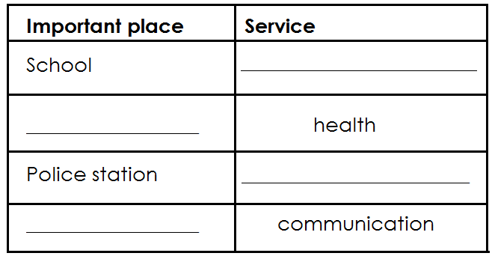

1. (a) The buying and selling of goods and services is called?

_____________________________________________________________

(b) Mention any **two** places where people buy goods from.

(i) ____________________________________________________________

(ii) ____________________________________________________________

(c) How are banks useful to people in our community?

________________________________________________________________

________________________________________________________________

1. a) Give the meaning of child abuse.

________________________________________________________________

_______________________________________________________________

b) Mention any **two** examples of child abuse.

(i) _______________________________________________________

(ii) _______________________________________________________

c) State any **one** cause of child abuse in our society today.

____________________________________________________________

____________________________________________________________

1. Which compass direction is opposite North East?

________________________________________________________________

(b) What is meant by the term **‘cardinal points’?**

________________________________________________________________

________________________________________________________________

c) Mention any **two** cardinal points of a compass.

(i) _______________________________________________________

(ii) _______________________________________________________

1. (a) What are social activities?

_______________________________________________________________

_______________________________________________________________

(b) Apart from circumcision, name any other two examples of social activities.

(i) _______________________________________________________

(ii) ______________________________________________________

(c) How are social activities important in the community?

_____________________________________________________________ _________________________________________________________

1. (a) Give **two** uses of electricity to people at home.
2. _________________________________________________________
3. _________________________________________________________

(b) How is electricity dangerous to people?

________________________________________________________________________________________________________________________

(c) Which type of electricity is generated from fast – flowing water?

____________________________________________________________

1. (a) State any **two** activities done by people to get money.
2. _____________________________________________________
3. _____________________________________________________

(b) Write down **two** problems facing people while doing their work.

(i) _______________________________________________________

(ii) _______________________________________________________

1. What is a tribe?

________________________________________________________________________________________________________________________________

(b) State any **two** ethnic groups in Uganda.

(i) _______________________________________________________

(ii) _______________________________________________________

(c) Name the largest tribe in Uganda.

______________________________________________________________

1. (a) Give any **two** reasons why population census is carried out in Uganda.
2. ______________________________________________________________________________________________________________
3. ______________________________________________________________________________________________________________

b) Write down any **two** problems faced by people in urban areas of Uganda.

(i) __________________________________________________________

____________________________________________________________

(ii) ____________________________________________________________

____________________________________________________________

1. Match the following correctly.

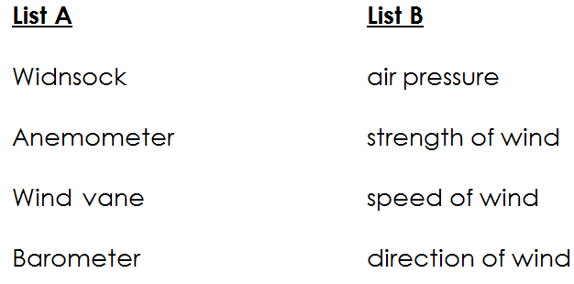

1. Windsock : ____________________________________
2. Anemometer : ____________________________________
3. Wind vane : ____________________________________
4. Barometer : ____________________________________

***E N D***